Quick review of chapter 1 and 2, ask to see questions, and give until the end of the next lass to have them done. PRAC next period
QUIZ: - Qualitative and quantitative
- Common analysis techniques
Gravimetric,Volumetric, Acid-Base titrations, Redox Titrations, Chromatography, Spectroscopic, Mass spec
- What is heating to constant mass?p11 (heat at 110 until the mass remains constant)
- How can we determine water content of something? Any problems with this method? (low b.p.)
- Analysis by mass: Gravimetric
- Briefly go back over mole n=m/MW (give sample problem)
Q 19. C) Calculate the amount in mole of H2O molecules in 20g of Cu SO4.5H2O

- Find molar mass of CuSO4.5H20
= 63.54 + 32.06 + (4x16) + (5x18)
=249.68 g/mol
- Calculate n (CuSO4.5H2O) = m/MW
= 20/249.68
=.0801 (3 sig figs)
- Look at stoic.. Since 1 mole CuSO4 = 5 mole H2O, therefore (.0801 x 5)
= 0.4005
- Sig figs = .401 mole

- Ideal Gas Equation pV=nRT (101.325 Kpa =1atm) t=K (+273)
Q 24
- Pv = nRT therefore n = PV/RT
- Convert variables into the correct units
P = 1 atm = 101.325 kPa
V = 991mL = .991 L
T = 24 C = 273+24 = 297K
- Sub in values
n = 101.325x.991/8.31x297
= 0.0407 mol (3 sig figs)
- What is molar mass of the gas?
- N = m/MW
re write: M = m/n
M = 1.22/0.0407
= 29.987 g mol-1
= 30.0 g/mol
- Look at appropriate gas weights… Combining N and O we get NO

- STP = 22.4L/mole (0deg 1atm)
- SLC = 24.5L/mole (25deg, 1atm)
- Empirical Formula (EXAM) make sure they have done the questions!

Q25
- Write out hr balanced equation (states)
- Calculate the amount in mole of Ag2 CrO4
n = m/MW
n = 0.778/331.74
= .002345 mol
- The stoic shows a 1:1 ration: Therefore there was 0.002345 mol potassium dichromate.
work out how much that is in grams:
n =m/MW
M = MW x n
= 0.4554g
sig figs = 0.455 grams
- DO the same with silver nitrate.

- Difference between empirical formula and molecular formula
- Talk about limiting reagent quickly, and have two solutions of lead nitrate, potassium iodide

- What allows us to do gravimetric analysis? (Known formula, low solubility, stable when heated, not form precipitates with other ions)
- EEI FRIDAYS LESSON, give out handout with the prac and background research, they will be expected to go home, read upon the prac, and do some background problems (student workbook page 47-58) so that they will be able to complete the practical.
New heading: Volumetric Analysis

Chapter 3, Concentration

N = cV, go over the different conversions

Look at units

Convert to grams per litre (convert by multiplying mol x MW

Give demos:
a) Make a 250mL solution of 3.2M NaOH

b) How many moles in 120mLs 2M HCl
- N=cv OR c=n/v (mol/L)

Discuss standard ways of measuring concentratrion
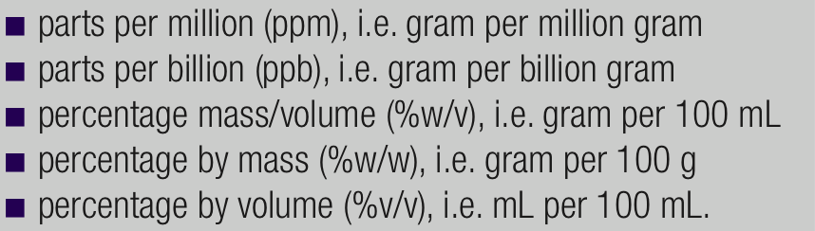
- Standard solutions (discuss) (bring in volumetric flask) prepared by dissolving a known mass of primary standard mass in an accurately known volume of solution
Explain how to use the meniscus etc
Explain some techniques for filling up the volumetric flasks
- Primary standards (substances that are so pure that the amount (in mole) of a substance can be calculated accurately from their mass.
These should be:
- readily obtained in pure form
- have aknown formula
- be easy to store without deteriorating or reacting with the atmosphere
- have a high molar mass to minimise errors in weighing.
- inexpensive
Look at common examples of acid and base primary standards
- Do question 3 in the book.
- Do question 4 in book.
Equivalence point 1:1 mole ratio
End point: Colour change ( close to equivalence point)
- Volumetric analysis, explain, then show how it can be achieved (demonstrate using pH indicators, as slowly changing pH of a solution)
- Define Titration, Aliquot, Pipette, Burette and show correct use of each apparatus. Equivalence point, titre, average.
- Discuss errors in the equipment (normally half the smallest division) p 32
- Do q 23
- Give kids a practical to do in the last lesson which incorporates a titration or a back titration and making of a standard solution. Photocopy from book

